New Attachment:

T = POLE TAG. REQUIRES A POLE PREFIX (MTE=, DRE=, OR NES=)

O = OHG

P = Tap (Pull off)

F = Future

COMMs:

F = FUTURE

T = TAG

C = C-Wire

D = Drop

E = Extend the strand

O = OHG

P = Tap (Pull off)

S = Self Supporting

V = Lash new cable to this strand

X = Strand not attached

ANYTHING BEFORE THE “=” WILL SHOW UP AS TEXT

EXAMPLE:

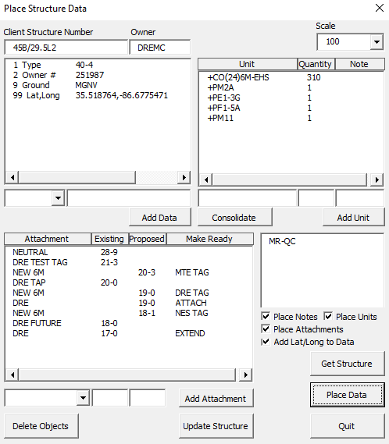 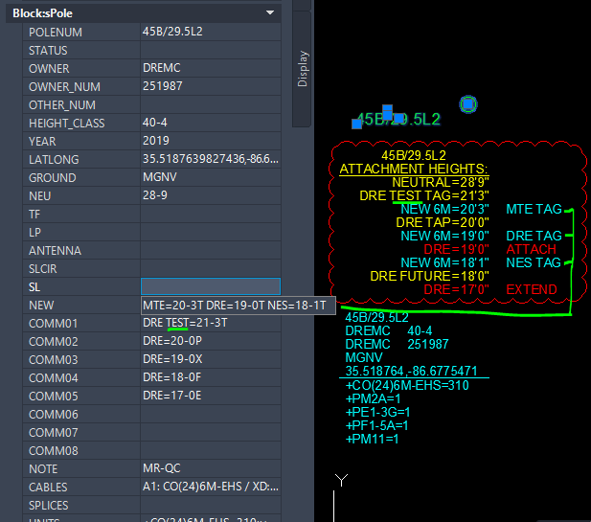

CHANGELOG

* 2.28.23 FA: ADDED “T” FOR NEW ATTACHMENTS TO IDENTIFY COMPANY OWNER AND TO ALLOW A PREFIX TO BE PRINTED IN THE ATTRIBUTES
* 2.28.23 FA: ADDED “F” AND “T” FOR FUTURE AND TAG RESPECTIVELY IN THE COMMS ATTACHEMENTS
* 2.28.23 GA: NOTED TO FIELDERS THAT THEY CAN ADD TEXT BEFORE THE “=” THAT WILL APPEAR AS TEXT IN THE CALL OUTS